NAME: Ajiya Anwar ROLL NO: DT-22006

a) date – shows the current date and time.

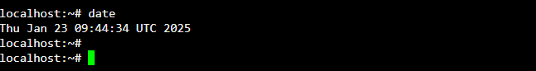

b) cal – used to display the calendar.

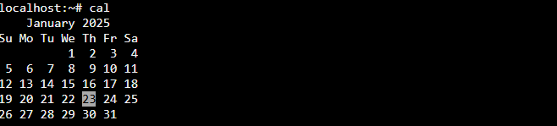

c) echo - used to print the message on the screen. E.g. echo “text”



d) ls - used to list the files. Your files are kept in a directory.



e) whoami – this command displays about the current user.



f) uptime - tells you how long the computer has been running since its last reboot or power-off.



g) uname - it displays the system information such as hardware platform, system name and processor,

OS type.



h) hostname – it displays the host name.



i) bc – stands for “best calculator”

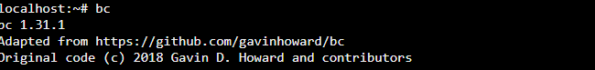

j) clear – this command clears the current screen.

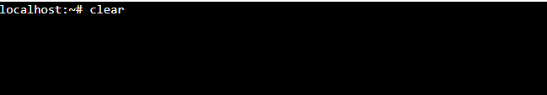

k) cat – this command is used for file manipulation. It is used to create, view and manipulate files.



l) rm – deletes a file from the file system.



m) wc - tells you how many lines, words, and characters there are in a file.

